Query Store Scenarios:

1. **Parameter Sniffing :**

**P.S:- Put a Disclaimer that it has to be validated and may not be fast always.**

1. **Database Upgrade :**
2. **High CPU :**
3. **Disk IO :**
4. **Memory usage :**
5. **Blocking (Dependent : Ref VSTS # 3512507) :**
6. **Identify Top Query Plans :**
7. **Slow Query troubleshooting:**
   1. **Query Lacks Proper Index :**
   2. **Finding Long Compiles Plans**
   3. **Datatype Mismatch**
8. **Attention Queries**
9. **Time taken by CLR**

**Scenario1: Parameter Sniffing. Intermittently query takes a long time to run**

**==========**

Here are the steps to repro an issue that can be caused by Parameter Sniffing: In this example data in large_table is not distributed evenly. For Id 1 to 9999 there is one row for each Id but for Id 10,001 there are 10,000 rows. Stored proc test_proc retrieves data from large_table based on the parameter @i. Let’s assume most of the time this SP will be called with @i = 10001. For that it will be better for the plan to do Table Scan instead of using Index Seek.

--Parameter Snoffing Example

drop table large_table

create table large_table (id int, name varchar(30), c3 binary(2000))

set nocount on

go

declare @i int

set @i = 1

while @i < 10000

begin

insert into large_table (id, name) values (@i, 'test')

set @i = @i + 1

end

set nocount on

go

-- Insert similar records

insert into large_table (id, name) values (100001, 'test')

go 10000

create index idx_large_table_id on large_table(id)

go

create procedure dbo.test_proc (@i int) as

select * from dbo.large_table where id = @i

--Stored proc was called for the 1st time with parameter 10 and this atypical parameter

--i.e. It is not used that oftem

exec test_proc 10 -- got the bad plan. Doing index seek

--now the plan is cached and it will use above plan irrespective of what parameters we pass

exec test_proc 100001 -- -- got the bad plan. Doing index seek. Plan good for parameter 10

-- to get rid of the bad plan let's clear the cache

dbcc freeproccache

--after the cache was cleared stored proc is called for the 1st time with the parameter that will be used most often

exec test_proc 100001 -- plan doing table scan

**To resolve the parameter sniffing issue using QS: (Note that this needs to be validated and may not be fast all the time)**

1. Identify the query (i.e. query id)

select query_text_id, * from sys.query_store_query_text

where query_sql_text like '%large_table%'

--got 168

select query_id, * from sys.query_store_query

where query_text_id = 168

--got 255

**2. Identify the good plan id**

You can use this query to identify multiple plans

--Queries with multiple plans

WITH Query_MultPlans

AS

(

select count(*) as cnt, q.query_id from

sys.query_store_query_text qt

join sys.query_store_query q

on qt.query_text_id = q.query_text_id

join sys.query_store_plan p

on p.query_id = q.query_id

group by q.query_id

having count(distinct plan_id) > 1

)

select q.query_id, object_name(object_id) as ContainingObject,query_sql_text,

plan_id, CONVERT(xml, p.query_plan) AS query_plan_xml,--p.query_plan as plan_xml,

p.last_compile_start_time, p.last_execution_time

from Query_MultPlans qm

join sys.query_store_query q

on qm.query_id = q.query_id

join sys.query_store_plan p

on q.query_id = p.query_id

join sys.query_store_query_text qt on qt.query_text_id = q.query_text_id

and q.query_text_id = 168 -- query_text_id we got from above

order by query_id, plan_id

**Got this sample output:**

query_id ContainingObject query_sql_text plan_id

255 test_proc (@i int)select * from dbo.large_table where id = @i 271

255 test_proc (@i int)select * from dbo.large_table where id = @i 273

**3. Force the query plan that you want the query to use**

exec sp_query_store_force_plan /*query_id*/255, /*plan_id*/271

To do the same thing from GUI , you can follow this steps:

Go to Query Store 🡪Tracked queries folder. Enter 255 in the tracked query. Select the plan you want to force and click on Force Plan:

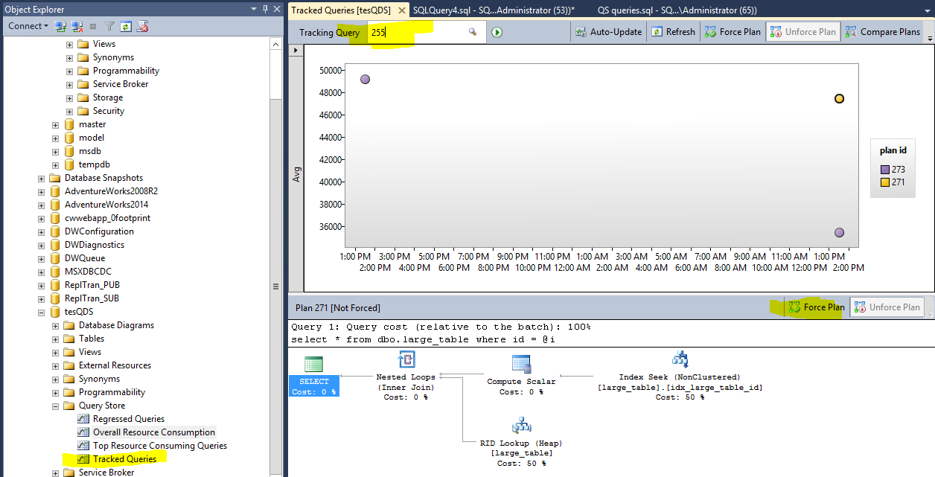

**Scenario 2: Database Upgrade**

**====================**

Query Store can be used to find out if the query performance regressed after the Databases are Upgrade say for e.g. SQL 14 to SQL 16 or if you apply any Service pack or CU. To do the same use the following steps:

* Enable QS before the database is upgraded
* Run your workload. Get the baseline.
* Upgrade the database
* Run your workload
* Check the Regressed Queries folder.

**Scenario 3: High CPU / Disk IO / Memory usage**

================================

If most of the queries are run on the SQL Server against the user database on which QS is enabled, we can use the query below to identify top queries that used the most CPU

--Query aggregates CPU for all finished queries executed in the last hour window and then returns top 25:

WITH AggregatedCPULastHour

AS

(

SELECT q.query_id, SUM(count_executions * avg_cpu_time) as total_CPU_time,

COUNT (distinct p.plan_id) as number_of_plans

FROM sys.query_store_query_text qt JOIN sys.query_store_query q ON qt.query_text_id = q.query_text_id

JOIN sys.query_store_plan p ON q.query_id = p.query_id

JOIN sys.query_store_runtime_stats rs ON rs.plan_id = p.plan_id

JOIN sys.query_store_runtime_stats_interval rsi ON rsi.runtime_stats_interval_id = rs.runtime_stats_interval_id

WHERE rsi.start_time >= DATEADD(hour, -1, GETUTCDATE())AND rs.execution_type_desc = 'Regular'

GROUP BY q.query_id

)

,OrderedCPU

AS

(

SELECT query_id, total_CPU_time, number_of_plans, ROW_NUMBER () OVER (ORDER BY total_CPU_time DESC, query_id) AS RN

FROM AggregatedCPULastHour

)

SELECT qt.query_sql_text, object_name(q.object_id) AS containing_object,

total_cpu_time AS total_cpu, number_of_plans,

CONVERT(xml, p.query_plan) AS query_plan_xml, p.is_forced_plan, p.last_compile_start_time,q.last_execution_time

FROM OrderedCPU od JOIN sys.query_store_query q ON q.query_id = od.query_id

JOIN sys.query_store_query_text qt ON q.query_text_id = qt.query_text_id

JOIN sys.query_store_plan p ON q.query_id = p.query_id

WHERE OD.RN <=25 ORDER BY total_CPU_time DESC

**You can do the same thing using the GUI**

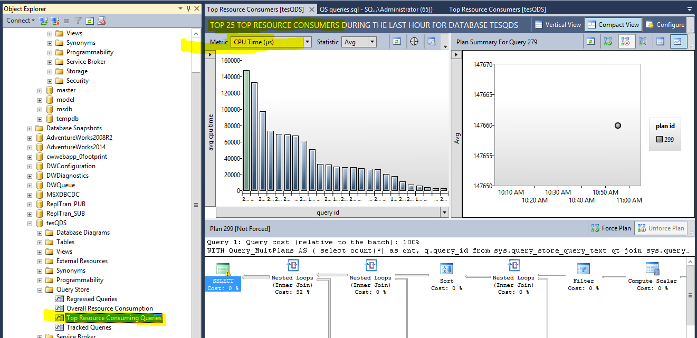

**8. Slow Query Performance troubleshooting:**

a. **Query Lacks Proper Index:** You can use this query to see what query plans have the missing index warning and its suggested impact for all the queries executed in the last 1 hour ordered by the average duration:

select qt.query_sql_text,

CONVERT(xml, p.query_plan).value('declare default element namespace "http://schemas.microsoft.com/sqlserver/2004/07/showplan"; (/ShowPlanXML/BatchSequence/Batch/Statements/StmtSimple/QueryPlan/MissingIndexes/MissingIndexGroup/@Impact)[1]' , 'decimal(18,4)') as Impact,

CONVERT(xml, p.query_plan) AS query_plan_xml,

q.query_id, qt.query_text_id, p.plan_id, getutcdate() as CurrentUTCTime, rs.last_execution_time, rs.avg_duration

from

sys.query_store_query_text qt JOIN

sys.query_store_query q ON qt.query_text_id = q.query_text_id JOIN

sys.query_store_plan p ON q.query_id = p.query_id JOIN

sys.query_store_runtime_stats rs ON p.plan_id = rs.plan_id

where rs.last_execution_time > dateadd(hour, -1, getutcdate())

and CONVERT(xml,p.query_plan).exist('declare default element namespace "http://schemas.microsoft.com/sqlserver/2004/07/showplan";/ShowPlanXML/BatchSequence/Batch/Statements/StmtSimple/QueryPlan/MissingIndexes/MissingIndexGroup/MissingIndex[@Database!="m"]') = 1

order by rs.avg_duration desc

**b. Queries with the longest compile time executed in the last one hour**

-- N queries with the longest compile time executed within last hour

select top 10 qt.query_sql_text, p.avg_compile_duration, q.query_id, qt.query_text_id, p.plan_id, getutcdate() as CurrentUTCTime, rs.last_execution_time, rs.avg_duration

from

sys.query_store_query_text qt JOIN

sys.query_store_query q ON qt.query_text_id = q.query_text_id JOIN

sys.query_store_plan p ON q.query_id = p.query_id JOIN

sys.query_store_runtime_stats rs ON p.plan_id = rs.plan_id

where rs.last_execution_time > dateadd(hour, -1, getutcdate())

order by p.avg_compile_duration desc

9.

**10. Time taken by CLR queries**

Let’s say we have an Update statement that uses a UDF function and that in turn calls a CLR assembly.

For e.g.

update Account_tbl_ENC set AcctNumber_RNDL = dbo.TryEncrypt(AcctNumber, 'None')

go

In this case TryEncrypt is a UDF function and that calls a CLR assembly. For this if we want to see how much time was spent on the CLR, you can use this query:

--Last N queries that were executed on the database

SELECT TOP 100 qt.query_sql_text, q.query_id, qt.query_text_id, p.plan_id, rs.last_execution_time, rs.avg_clr_time, rs.max_clr_time,rs.avg_cpu_time, rs.max_cpu_time, rs.max_dop, rs.avg_duration, rs.max_duration, rs.max_rowcount, CONVERT(xml, p.query_plan) AS query_plan_xml

FROM

sys.query_store_query_text qt JOIN

sys.query_store_query q ON qt.query_text_id = q.query_text_id JOIN

sys.query_store_plan p ON q.query_id = p.query_id JOIN

sys.query_store_runtime_stats rs ON p.plan_id = rs.plan_id

ORDER BY rs.last_execution_time DESC